
JUDE’S NEWS
26th May 2026

Office Closed
The office will be closed Wednesday 27th May.

Archbishop's Certificate Module 2
See link below for all the information. Please let Andrea know if you are enrolling so that she can encourage and support you.
https://events.humanitix.com/archbishop-s-certificate-module-2-handling-the-bible-2026

We farewell the Parkins family with grateful hearts and thank them for their service and contribution to the life of St Jude’s. We wish them every blessing as they begin this exciting new chapter and adventure ahead.

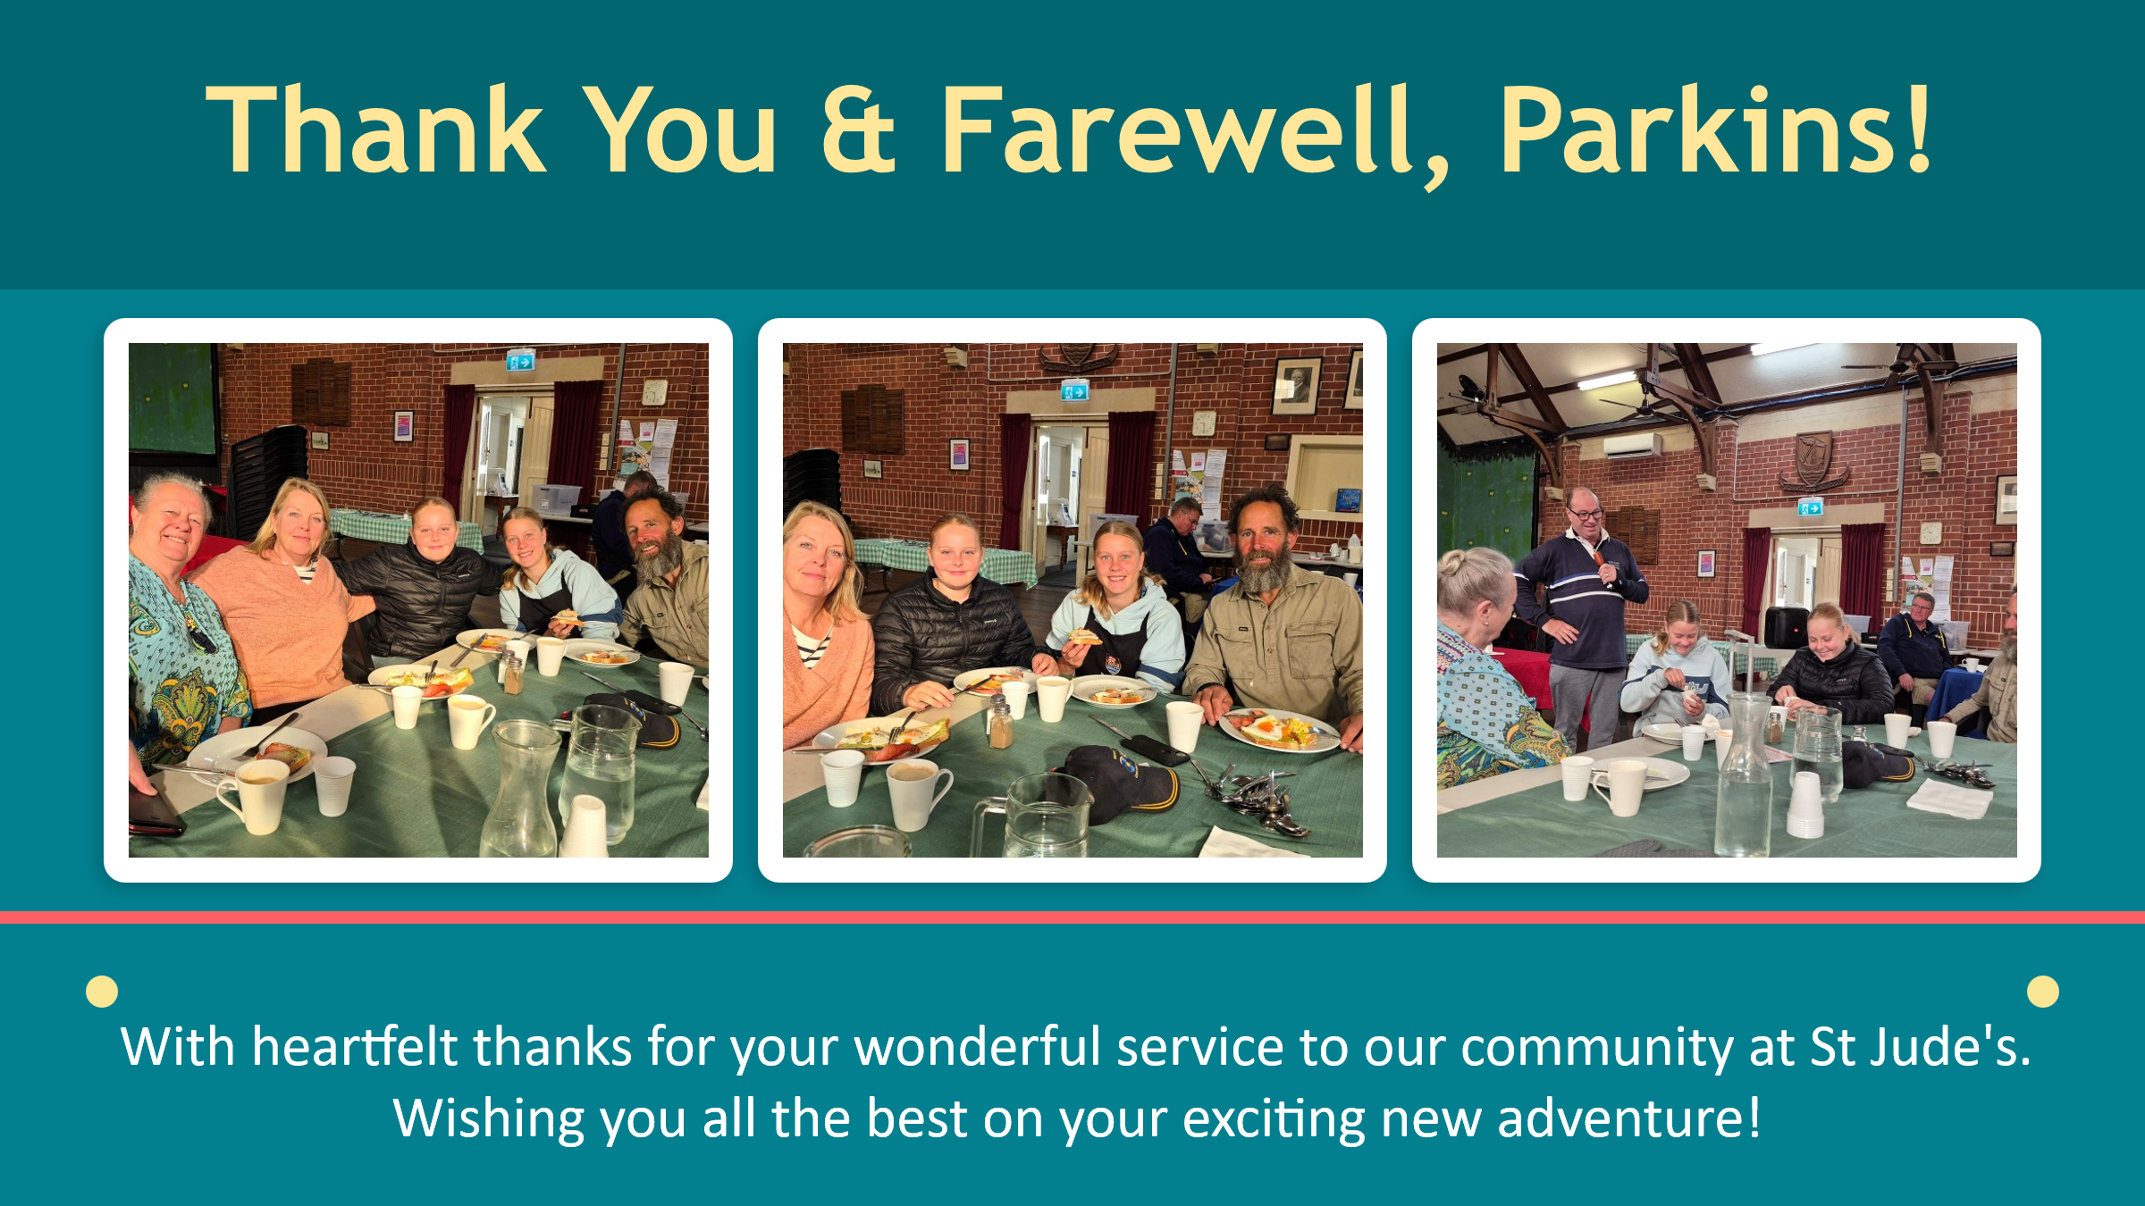

ACVVS Volunteer needed
St Jude’s Volunteer Visitor Program is currently looking for a new volunteer who would be interested in visiting a lady who is living in her own home in the South Plympton area. This lady’s ideal volunteer would be aged 50+, with a local background and of Christian faith. She would welcome either a female or male visitor. If you have an hour or two per fortnight free and would like to know more about this volunteer opportunity, please feel free to give me a call on 0411 731 532, or email fieldkaren19sj@gmail.com.
Karen Field, St Jude’s ACVVS Coordinator.



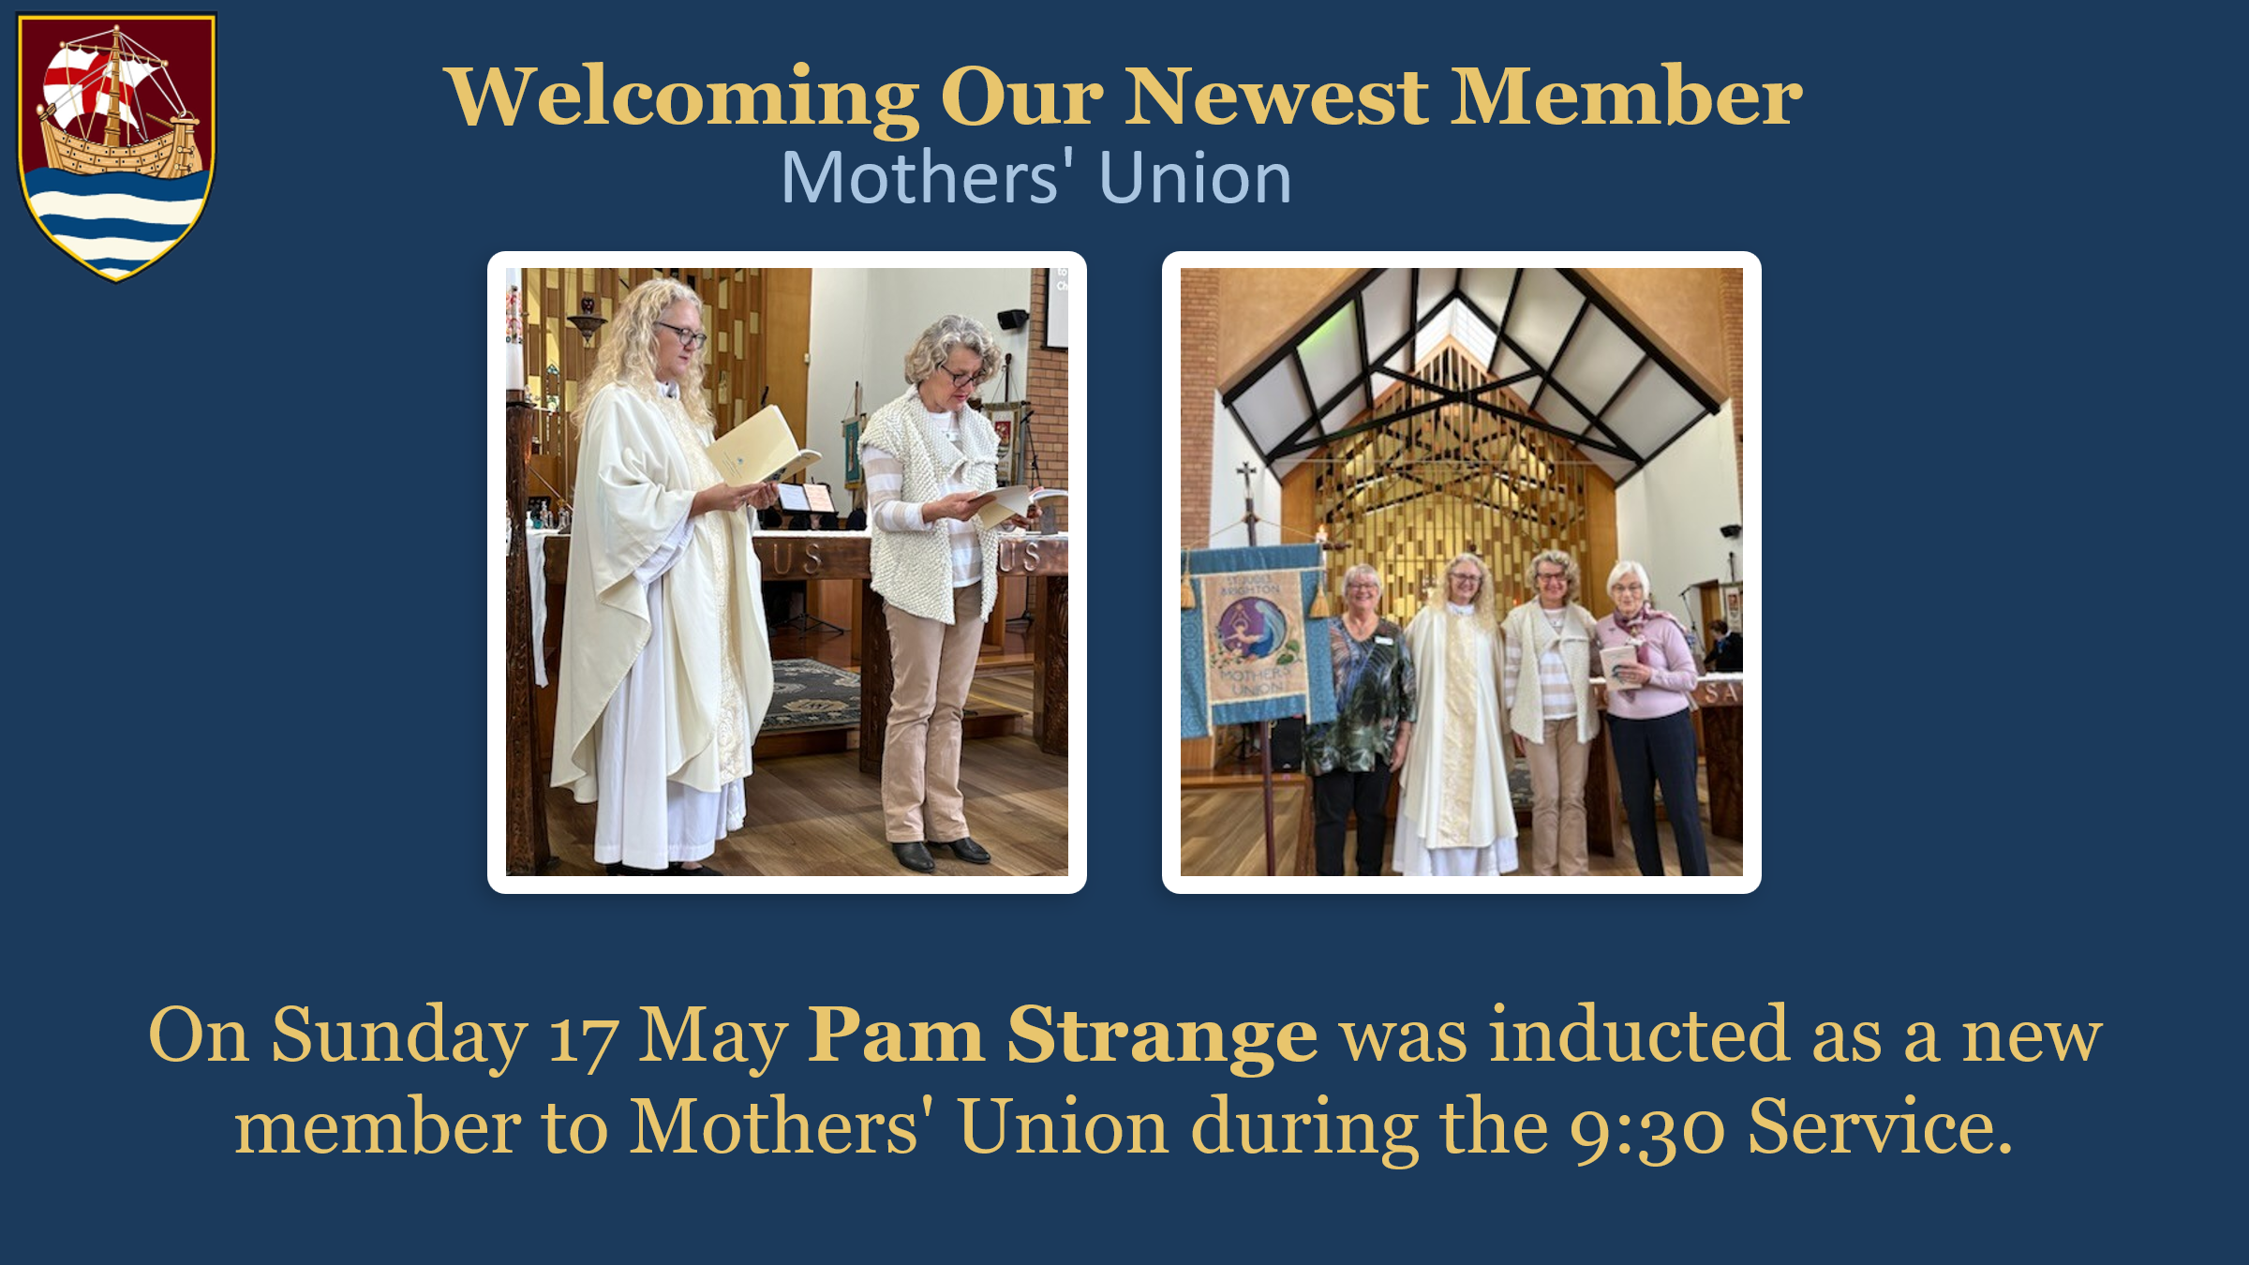

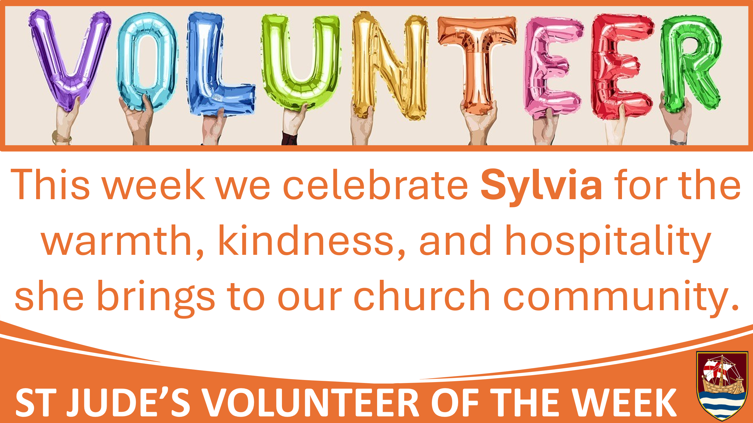
Volunteer of the Week: Sylvia
This week we are delighted to recognise Sylvia as our Volunteer of the Week. Sylvia is a friendly and welcoming presence at St Jude’s, helping people feel at home through her service as a welcomer and by assisting with morning tea. This year, she has also stepped into a new role as a member of Parish Council, continuing her commitment to supporting and strengthening our church community. Alongside this, Sylvia lovingly writes and mails the birthday cards sent on behalf of St Jude’s, helping parishioners feel remembered, valued, and connected. We are grateful for Sylvia’s kindness, warmth, and willingness to serve in so many thoughtful ways. Thank you, Sylvia, for all that you do!

Reminders

Clergy Retreat/Annual Leave
Andrea will be taking annual leave from 29 May to 20 June. Rev’d John will offer services and be available for pastoral care during this time. For any parish matters during this time please speak to Wardens, Roger or Virginia.

Pauline Glover Funeral
We give thanks for her dedication and service, and hold her family and friends in our prayers at this time. Pauline’s funeral will be held on Thursday 28 May at 11am at Centennial Park.
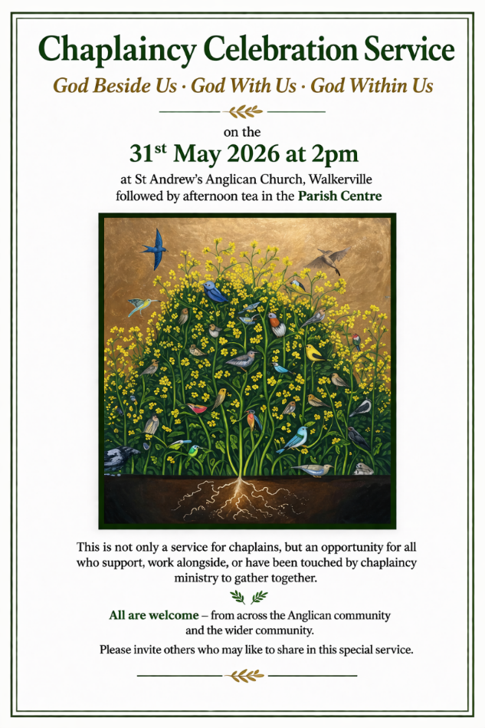
Celebrating Chaplaincy
The month of May is a time to celebrate chaplaincy in Health, Anglicare Sa, Anglican Schools, and the Community. You are encouraged to keep our chaplains in your prayers this month. See image for the diocesan service to celebrate chaplaincy.

Prayer of the week
Almighty God, at the feast of Pentecost you sent your Holy Spirit to the disciples, filling them with joy and boldness to preach the gospel: empower us with that same Spirit to witness to your redeeming love and draw all people to you; through Jesus Christ our Lord, who lives and reigns with you and the Holy Spirit, one God, now and for ever.
Amen

Prayer List:
Alan, Andrew, Barbara, Christopher, Craig, Draginja (Holly), Emerson, Faye & Sarah, Jane, Joy, Lange, Lesley, Lilly, Lola, Marilia, Norma, Peter, Peter & Kath, Rachel, Robin, Sabrina, Sidney, Stuart, Susie, Sylvia.

