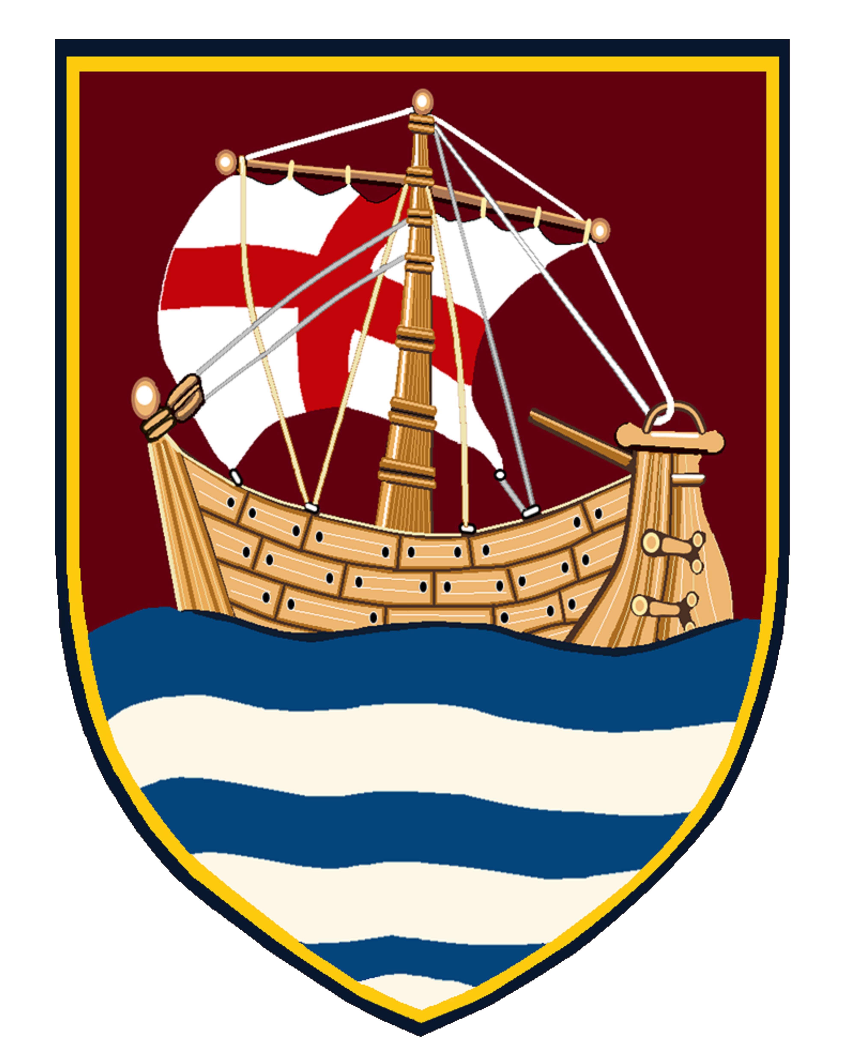
Community Meal Roster April – June 2026
Friday 11.30am-1.30pm

Date | Volunteers
Fri 03 Apr 2026  Good Friday | Michelle Blewitt, Pam Parkin, Jeremy Zieseniss, Louise Zieseniss, Chantel Peacock, Maureen Skinner
Fri 10 Apr 2026 | John Neeves, Rosey Neeves, Tim Butler, Julia Butler, Ellie Gharib
Fri 17 Apr 2026 | Kids + Maureen Skinner
Fri 24 Apr 2026 | Kids + Maureen Skinner
Fri 01 May 2026 | Michelle Blewitt, Pam Parkin, Lange Powell, Inara Powell, Jackie Glover
Fri 08 May 2026 | Heather Felgate, Jenny Stewart, John Candy, Judy Vowles, Kath Fisher
Fri 15 May 2026 | Pam Parkin, Margaret Hooper, Pam Binks, Robyn Everitt, Vari Booth
Fri 22 May 2026 | Tineke Thurlow, Chantel Peacock, Ellie Gharib, Heather Felgate, Jackie Glover
Fri 29 May 2026 | Pam Parkin, Jenny Stewart, John Candy, Judy Vowles, Maureen Skinner
Fri 05 Jun 2026 | Michelle Blewitt, Margaret Hooper, Robyn Everitt, Vari Booth, Chantel Peacock
Fri 12 Jun 2026 | Pam Parkin, Tineke Thurlow, Jeremy Zieseniss, Louise Zieseniss, Ellie Gharib
Fri 19 Jun 2026 | John Neeves, Rosey Neeves, Tim Butler, Julia Butler, Heather Felgate
Fri 26 Jun 2026 | Pam Parkin, Jackie Glover, Jenny Stewart, John Candy, Judy Vowles

