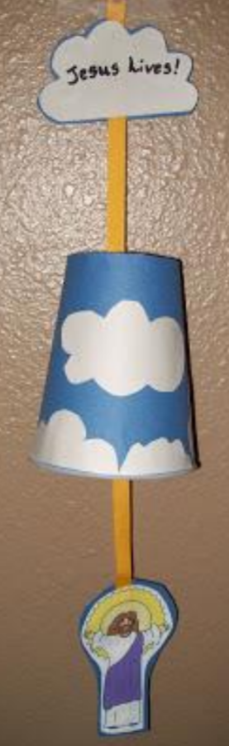
Craft:
You will need:
• Scissors
• Glue
• some white and blue construction paper or
cotton wool
• some ribbon or wool
• a paper cup
• a printout of Jesus or if you are artistic you may
enjoy drawing Jesus.
First cut into the bottom of a cup a small slit for the
ribbon (maybe ask for help from an adult with this
bit) flip the cup upside down, then glue blue paper
on the outside of the cup.
Next cut out cloud shapes from white construction paper, and glue them
around the cup to represent the sky with clouds or stick on cotton wool
balls.
Then print out a picture of Jesus that will fit inside the cup or draw it.
Cut out the picture. Also cut out a cloud for the top piece, like shown in
the picture.
Using a glue stick, glue the paper Jesus to the ribbon.
Thread the ribbon through the hole in the bottom of the cup, so that by
pulling the ribbon, you can pull Jesus up into the cup.

