Third Sunday After Pentecost Activity
Bubbles! I wonder if you have any bubbles lying about at home? If not maybe you could make your own mixture and bubble wand? (instructions below).
Can you blow bubbles outside and imagine that each bubble represents all the people that GOD loves and cares for.. . When each bubble POPS, remember that God knows and CARES about everything that happens to us. Watch as the bubbles travel in the wind, moving and spreading Gods Word, Love and care.

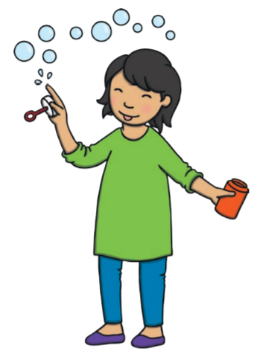
Bubble Mixture Recipe
475ml of water
15ml of dishwashing liquid
Bubble wand Ideas
Pipe cleaners
Wire coat hangers (be careful of sharp ends!)

