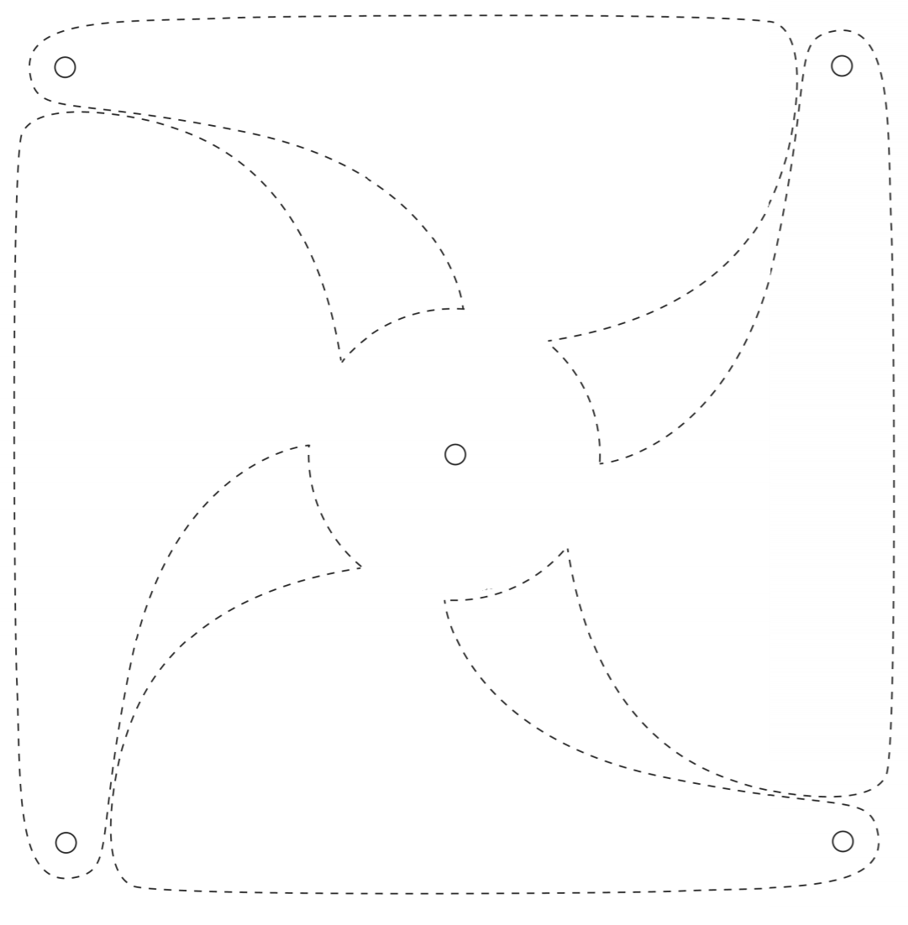

Can you make your own pin wheel?

Perhaps you could put it in your garden and watch how the wind makes it spin.

You will need:

This template

Scissors

Colouring pencils

Split pin

Sticky tac

Straw

Instructions:

1. Colour in the template on both sides
2. Cut out using the dotted lines
3. Fold the small circles at the ends to meet the circle in the centre.
4. Push the split pin through the circles.
5. Push the pin through the straw being careful to secure the back of the pin with sticky tac.
6. Test you pin wheel in the wind.