St Jude’s WW2 Honour Roll
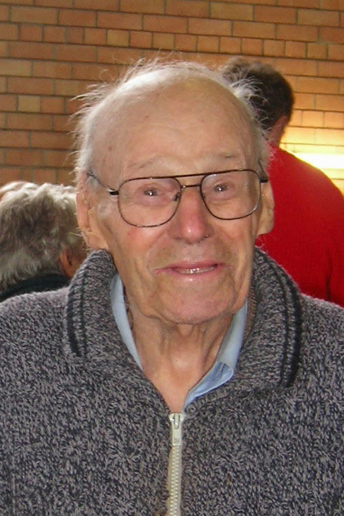
Keith Gerrard
Australian Army
SN: SX33264
Enlisted 13.10.1943
Rank: Sergeant (Signalman)

Keith and brothers, Alan and William (Bill), all enlisted after the war broke out. Keith and Alan joined the army and Bill enlisted in the RAAF in 1940 to be a pilot. He was a Sergeant in the Construction Squadron and served in the Solomon Islands. Alan enlisted in 1941 and served in Darwin when it was bombed and Tarakan, Borneo. Keith, with his Morse Code ability, became a Sergeant Signalman in the Army and saw service in New Guinea and Bougainville. Keith remembered Hughie Francis and his brother; two sons of the rector’s warden Mr Good as well as the two boys from the Isaachsen family who all did not return. When on leave from the war both Keith and Alan would attend church in their uniforms and were actively involved as sidesmen and delivered the parish news on their push bikes.
Before the war Keith’s first job was with the SA Brush Co (SABCO). He then joined the railways where he was taught the Morse Code. When he was discharged in 1946 he got a job at Waipinga, near Victor Harbor on a dairy farm. He had to bunk in the dairy shed and was pestered by mosquitoes. After a few weeks he got a job at the SA Rubber Mill (late Uniroyal). Around 1949 he got a job at ETSA as a meter reader. After the war it was difficult to get a good job but with the government came security. He stayed with ETSA for 30 years until he retired at the age of 60.
Keith was a Sunday School teacher and an original member of the St Jude’s Players. He also played doubles tennis with his brother Alan for St Jude’s. For many years Keith attended St Jude’s working bees and helped Laurence with the gardening.
Keith died in June 2011.
Source: Murray Sibley (Eulogy at St June’s 5 June 2011)

