St Jude’s WW2 Honour Roll
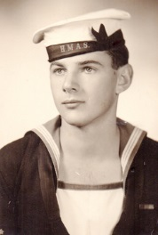
Bruce Shearer Swann
Royal Australian Navy
SN: PA3135
Service: 8.9.1942 – 30.4.1946
Rank: Able Seaman

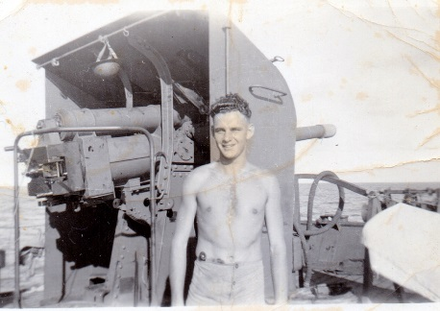
Bruce Swann was born 20 August 1925 in Brighton. His parents, James and Thelma lived at 7 Rutland Avenue, Brighton. They were parishioners at St Jude’s and Bruce attended Brighton Primary School before Pultney Grammar School. Bruce loved the sea and sailed with the Brighton and Seacliff Yacht Club. He began work at the age of 17 in 1941 with the pastoral house and wool broker, Goldsborough Mort and Co.
Bruce enlisted in the Australian navy in September 1942 and after training began service attached to the American navy. His main service was on the Corvette HMAS Bendigo. As well as that he was attached to the British Pacific Fleet. While he was on service he had the time to discover that he enjoyed sketching as a pastime. On the right Bruce is with a 4 inch gun on the Bendigo
After the war Bruce returned to work with Goldsborough and Mort Co and then worked for Elder Smith and Company for 33 years as a stock agent. This work enabled him to travel and see a great deal of Australia’s countryside. He also married Clem in 1948.
Gradually Bruce became more and more involved with his sketching which developed into water colours and oil painting. He became successful with his work being exhibited widely as well as a number of books of his work published. In 1977 two of his paintings were purchased for Queen Elizabeth and Prince Phillip’s private collection. In 1986 one of his outback paintings was presented to Pope John Paul 11 and in the same year 8 outback paintings were purchased for the New Parliament House collection in Canberra.
Bruce struggled with his health and experienced three heart attacks before the final one took his life on 21 November 1987. He was 62 and his ashes are in the St Jude’s cemetery accompanied by a plaque. He is remembered in the book ‘In The Wake of St Jude’ by Lochee Andison as he provided sketches for the book as seen below.

Sources: RSL Virtual Memorial, AWM, ‘In The Wake of St Jude’ by Lochee Andison
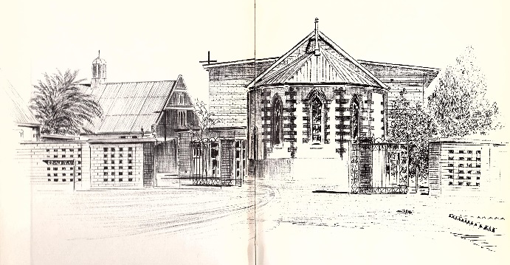
Afte

