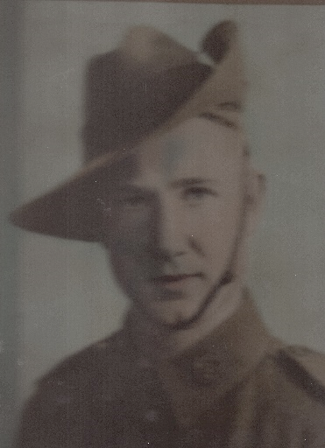
St Jude’s who served
Brian Richard Woollard
World War 2
Army
SN: SX35619
Corporal
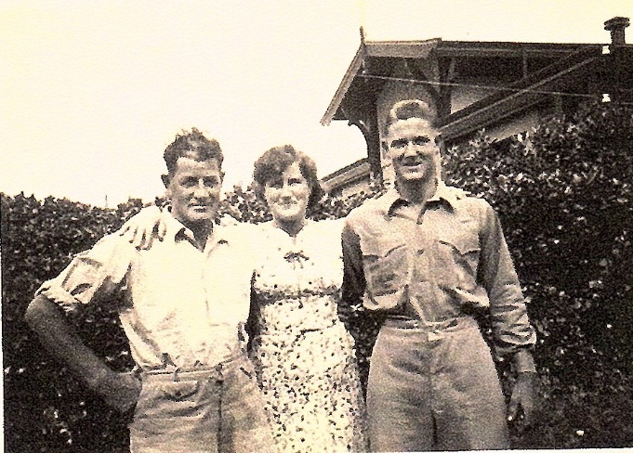
Brian was the brother of Tarlie Dack (nee Woollard) Isabella Norton (nee Woollard) and Sybil Woollard. He was born 21 October 1922 in Brighton and with his siblings attended church and Sunday school at St Jude’s. After graduating from Adelaide University as an Electrical and Mechanical Engineer his first job was in the Army based at Keswick. He enlisted 21 March 1945 and served in New Guinea. He was fortunate to return to South Australia but unfortunately due to an operation in New Guinea during the war he died from peritonitis. He died on 10 October 1947 and is buried in St Jude’s cemetery. He is on the right in the picture with Tarlie in the middle and Alec on the left.
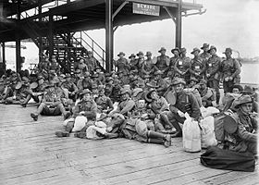
Tarlie, Isabella, Sybil and Brian had two great uncles who were involved with WW1. Both Herbert (SN: 3922) and John (Jack) (SN:3927) Woollard joined the 10th reinforcements to the 5th Pioneers in June 1917. Both were privates. Although they were trained as infantrymen the main purpose of the 5th Pioneers was to carry out engineering and other trade functions in the field. In France during 1917 the 5th Pioneers worked on extending railway lines, tunnelling, building roads etc. They would be in this photo taken of the 10/5th Pioneer reinforcements preparing to leave Port Melbourne in October 1917
John (Jack) was married to Olive Maud Gregory in St Jude’s 1908. The Gregory family were also members of St Jude’s congregation. At one time he was Captain of the Port Adelaide Football Club. Herbert did not marry but lived in a cottage built by William Voules Brown on the corner of Brighton Road and Voules Street. They are both buried in St Jude’s cemetery.
Sources: Tarlie Dack, NAA Service Records, Wikipedia.org/wiki5th_Pioneer_Battalian, Photos of Brian from Tarlie Dack

