St Jude’s who served
Robert George Thiselton
WW2
4th Battalion Volunteer Defence Corps
SN: S65550
Private
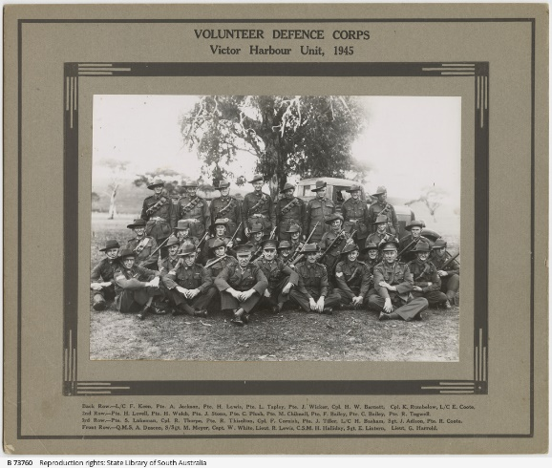
Robert George Thiselton was born in Brighton 4 September 1899 to Robert George and Frances (nee Palmer) Thiselton. His father owned property in Brighton on which he kept sheep and cattle as well as a vineyard at Darlington. He also kept horses in paddocks between Shoreham Road and Oleander Street. He was also the lessee of the Brighton to Glenelg horse-tram from 1888 to 1914. Between 1906 and 1909 he was also Mayor of Brighton. His brother farmed at Cowell and it is here that Robert met and married Mary Louise Fidler who was brought up by her aunt and uncle in the Hornhardt family. They were farmers in Cowell. Robert and Mary moved to Victor Harbor to live and farm but their son Malcolm Robert Thiselton moved to Brighton and his granddaughters Rosey Neeves and Didy Button attend and are actively involved in St Jude’s.
Robert was too old to serve abroad during WW2 but enlisted 15 April 1942 in the Voluntary Defence Force. As Australia was threatened with attack from the Japanese they played a crucial role in preparing for defence on Australian soil and were consequently fully trained soldiers. Many in reserve occupations belonged to these forces. Robert was discharged 15 October 1945. Robert is included in the photo on the right.

Frederick William Thiselton
WW1 Middle East
3rd Light Horse
SN: 2949
Robert’s uncle and Rosey’s and Didy’s great, great uncle Frederick, born in Brighton, served in Egypt and Palestine after enlisting 24.3 1916. He was deployed in the Nile Valley to protect the Sinai Peninsula from pro Turkish invaders. He was at Rafa and the Battle of Magdhada and Es Salt. Later he was part of the support force for the British Offensive against the Germans and Turks in Palestine. He was discharged 26.6.1919. He is commemorated on the Arch of Remembrance, Brighton.
Sources: State Library of South Australia; Australian War Memorial; NAA Service Records; ‘The Vanishing Sands’ by Averil Holt; Ancestry.com.au

