St Jude’s WW2 Honour Roll
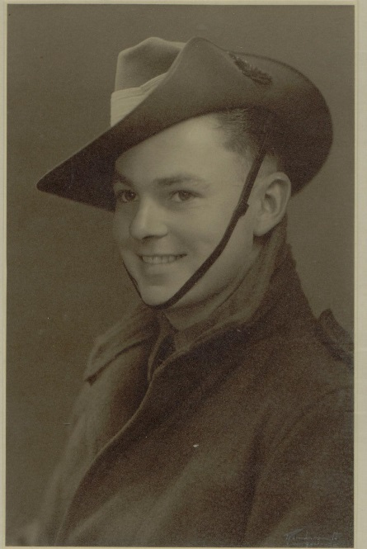
Roland George Gregory
Australian Army
SN: SX19147
Service: 9.2.1943 – 4.1.1946
Rank: Sapper

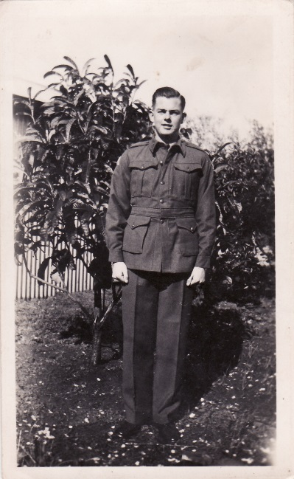
Roly was a survey draughtsman with the Department of Lands prior to his enlistment and spent his time in the army in the 5th Australian Forward Survey Company preparing maps from aerial photographs. Toward the end of the war he was posted to the Indonesian Island of Morotai where he witnessed one of the official signings of surrender by the Japanese.
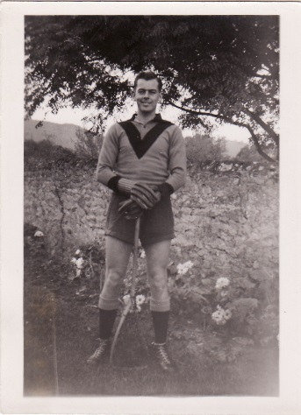
Roly grew up in Brighton and lived at 27 Edwards St. His family were parishioners at St Jude’s and he attended Brighton Primary School and Adelaide Technical High School. After the war Roly returned to the Department of Lands where he worked as a draughtsman and cartographer until his retirement in the eighties.

He played lacrosse and cricket for Brighton clubs for many years in the 1940s and 1950s. Roly in lacrosse uniform.

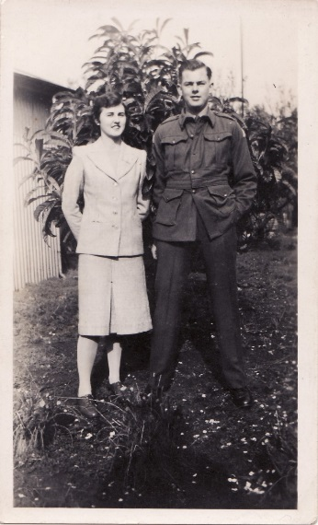
Roly married Barbara Reusch whose family were also parishioners at St Jude’s during the war years. They were married at St Jude’s in 1947 and lived nearly all their married life at 6 Kildonan Road, Warradale. Barbara died 8.1.1992 and Roly died 8.4.2004 and their memorial plaques are attached to the wall in St Jude’s Memorial garden.
Roly with Barbara Prepared by Roly’s son John Gregory

