St Jude’s who served
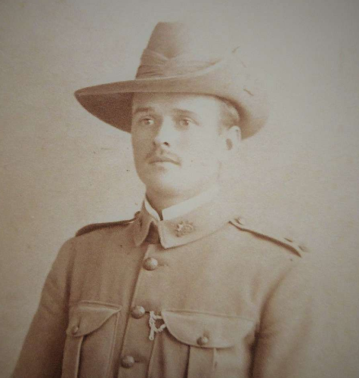
Edgar Alexander Luxmore
Boer War: 1902
Unit: 2 Battalion Australian Commonwealth Horse
SN: 971
Corporal
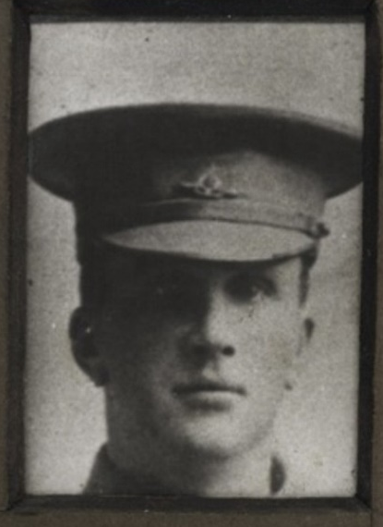
Ernest Marshall Luxmore
WW1: 26.5 1915 – 26.11.1919
9th Light Horse Regiment
Lieutenant: Gallipoli; Middle East

Awarded the Military Cross: 6/9/18

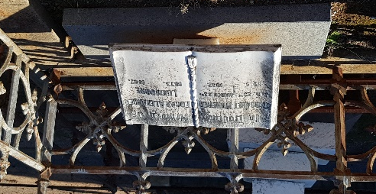
Both Edgar and Ernest were born to St Jude’s pioneers John Henry and Margaret Luxmore. Both parents contributed a great deal to St Jude’s history (fundraising, French Hall, Church Warden, Young Men’s Social Club (of which Ernest was a member). Their remembrance is seen in the stained glass window to the Annunciation in the Chapel and the pulpit in the church.
Edgar married and lived in the Transvaal after marrying in South Africa but returned with his family to South Australia in 1910 and is buried in St Jude’s Cemetery. He was a Church Warden in 1918 and Trustee in 1919 and 1920.
Ernest was a very successful swimmer and well known for his lifetime of leadership in the Adelaide Hunt Club. He was married by Canon Best (Rector of St Jude’s 1925 – 1936) at St Peter’s College 9 Dec 1920. His two daughters served in WW2. Sadly, while Ernest was serving in the Middle East both Margaret and John died within two weeks of each in November 1916 and are buried in St Jude’s Cemetery.
Sources: RSL Virtual Memorial, NAA Service Records, Trove Online newspapers, Ancestry.com.au, ‘In The Wake of St Jude’s’ and photo of grave by Kath Fisher

