St Jude’s WW2 Honour Roll

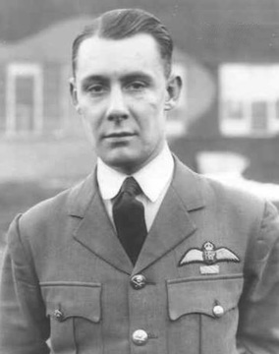
†Duncan Charles Frederick Good
Unit No 50 Squadron (RAF)
SN 39459
Royal Australian Airforce
Rank: Squadron leader

Duncan Charles Good was born in Adelaide to William Duncan Good and Magdalene Good (nee Innes). They lived in Dunrobin Road, Brighton. William was a Church Warden at St Jude’s Brighton from 1935 to 1956 and a Trustee of the church from 1935 to 1955.
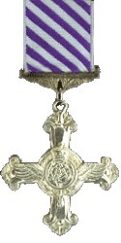
Duncan had been transferred to the RAF and married Elsie Betts of London. On 17 May 1940 his named appeared in the London Gazette for being awarded the Distinguished Flying Cross.
A year later Duncan unfortunately died on 28 April 1941 and he was lost at sea near France. The Adelaide Advertiser records on 5 may 1941 that Duncan was ‘engaged in a night reconnaissance and after having been wounded by a shell bursting in the cockpit he completed his task, despite anti-aircraft fire and search lights, and collapsed from loss of blood.’

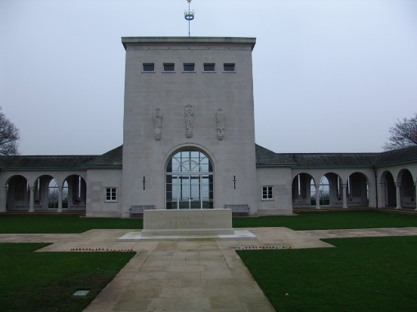
There is no grave from Duncan but he is listed on the Memorial Board at Runneymede Cemetery, Surrey, England.
Photo left
Sources: RSL Virtual Memorial, Trove online newspapers, Anderson, Lochee, In the Wake of St Jude.

