St Jude’s who served
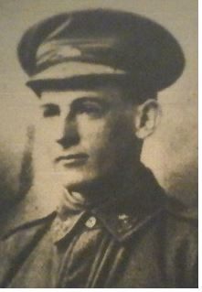
Cyril Gilbert Holt Counsell
WW1 Western Front
32nd Infantry Battalion
SN: 3535
Private

Cyril was born 7 November 1895 in Rose Park to Samuel James Harry and Alice (nee Whyte) Counsell. They moved to Brighton around the turn of the century where Samuel was clearly involved with St Jude’s. Between 1912 and 1919 he was church warden and in 1913 he was appointed as a trustee. He held this post until his death in 1925. During 1913, as warden, Samuel was involved in investigating means of acquiring a rectory for the Parish. He lived in Old Beach Road and with blocks of land adjoining his own they were made available for a rectory to be built in 1915. Clearly, Cyril was brought up in St Jude’s.
Cyril attended St Peter’s College where he served for two years in the Senior Cadets. After school Cyril worked at a few jobs and while working on his uncle’s sheep station in Queensland he decided to return to Adelaide to enlist in the AIF. On 10 April 1916, he was posted to B Company, 2nd Depot Battalion, at Mitcham Camp and from there joined the 8th reinforcements for the 32nd Battalion and eventually reached the western front on 7 February 1917.
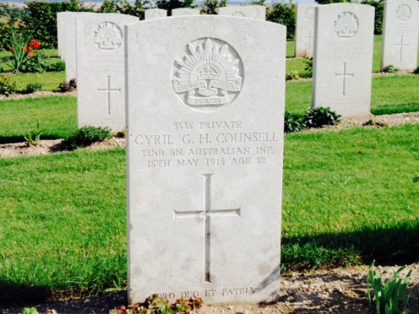
The 32nd Battalion was engaged during the second Battle of Bullecourt in Belgium and in September 1917 took part in the Battle of Polygon Wood, Belgium. After being wounded in action on 1 October 1917, Private Counsell was admitted to 3rd Australian Field Ambulance with wounds to his head and back and transferred to 18 General Hospital, Camieres the following day. He rejoined his unit in the field on 14 October and was granted leave in England 10 – 27 February. On his return he resumed his position as a Lewis Gunner in B Company. Private Cyril Counsell was killed in action near Sailly-le-Sec on 15 May 1918. He was 20 years of age. He is buried at Villers-Bretonneux Military Cemetery Plot 1 Row B Grave 8 (right)
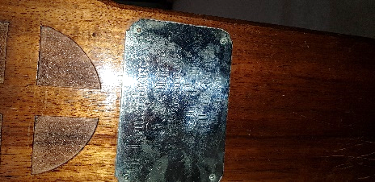
Cyril and his father are commemorated on a plaque at the end of the prayer desk next to the lectern in the Chapel.

Sources: Virtual War Memorial (RSL); NAA Service Records; Commonwealth Graves web site; ‘In The Wake of St Jude’s’ and photo of plaque by Kath Fisher

