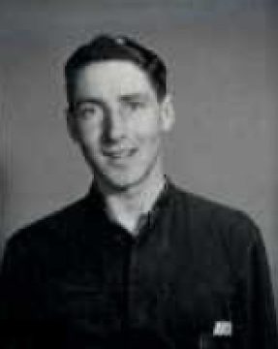
St Jude’s WW2 Honour Roll
Alan John Crabb DFC
No 466 Squadron RAAF
SN 417620
Service: 20.6.1942 – 19.9.1947
Flying Officer, Flight Lieutenant

Alan Crabb was born 24 May 1923 and lived at 3 Murray Street, Brighton and attended St Jude’s as a child and young man. He was popular with the girls and a keen sportsman. He began his working life as a clerk.
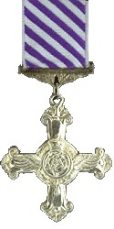
Alan enlisted with RAAF in June 1942 and did his training at Mallala and Parafield. In May 1943 Alan transferred to England where he was trained to fight in Haliflax aircraft. He did a large number of missions against the enemy which included two tours of duty, He began as a Flying Officer and acted as aircraft bomber. He eventually achieved the rank of Flight Lieutenant.
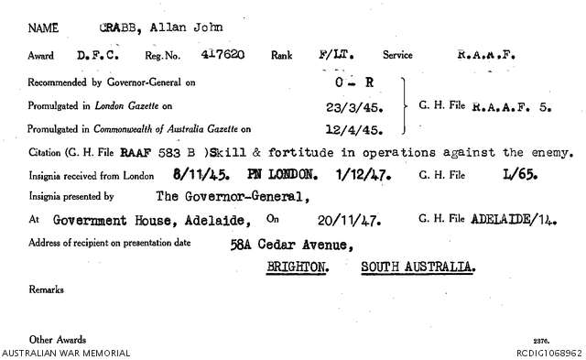
On 23 March 1945 the London Gazette recorded the citation of the Distinguished Flying Cross being awarded to Alan Crabb for skill and fortitude in operations against the enemy. He eventually received his medal from the Governor-General at Government House in Adelaide on 20.11.1947. By then he was living at 58A Cedar Avenue, Brighton.
Alan went on to be highly regarded as a football player for Glenelg (1949 – 1956) and South Australia. He played as a Ruckman and captained Glenelg in 1949 and 1955/6. In 1949 he was runner up for the Magarey Medal. He also worked as a pilot for the Australian National Airways.
On 23 May 1959 Alan married Elsie Murphy and he died of natural causes on 11 February 1982.
Sources: RSL Virtual Memorial, National Archives Service Records, Trove Online newspapers

